Project Title

Software Requirement Specifications
Bachelor of Science in Software Engineering
By

 | Name | Registration # | Mobile # | E-Mail
1
2

Supervised by Co-Supervised by

___________________ ___________________
Teacher Name Teacher Name



Department of Software Engineering
Lahore Garrison University
Lahore
Table of Contents
1. Introduction 4
1.1 Purpose 4
1.2 Document Conventions 4
1.3 Intended Audience and Reading Suggestions 4
1.4 Product Scope 4
2. Overall Description 4
2.1 Product Perspective 4
2.2 Product Functions 5
2.3 User Classes and Characteristics 5
2.4 Operating Environment 5
2.5 Design and Implementation Constraints 5
2.6 User Documentation 5
2.7 Assumptions and Dependencies 6
3. External Interface Requirements 6
3.1 User Interfaces 6
3.2 Hardware Interfaces 6
3.3 Software Interfaces 6
3.4 Communications Interfaces 7
4. System Features 7
4.1 System Feature 1 7
4.1.1 Description and Priority 7
4.1.2 Stimulus/Response Sequences 7
4.1.3 Functional Requirements 7
4.2 System Feature 2 (and so on) 8
5. Other Nonfunctional Requirements 8
5.1 Performance Requirements 8
5.2 Safety Requirements 8
5.3 Security Requirements 8
5.4 Software Quality Attributes 8
5.5 Business Rules 9
5.6 Detailed Subsystem Design 9
References 9

1. Introduction

1.1 Purpose
The purpose of this Software Requirements Specification (SRS) is to outline the requirements and objectives for MoodGenie, an AI-powered mental wellness application designed to support software developers, research scholars, and tech students who experience high stress and burnout due to demanding workloads and cognitive strain. The application integrates AI-driven emotional support, secure therapist access, and mood tracking analytics into one unified, privacy-first system to promote mental well-being within the technology community. Mental health has become a critical concern globally, with one in four individuals expected to experience a mental or neurological disorder in their lifetime [1]. Research also indicates that individuals in technical professions report higher rates of anxiety, depression, and work-related burnout compared to other fields [2]. Existing solutions such as Wysa, Woebot, and Youper provide partial support but lack personalization, therapist integration, and affordability for students [3][4][5]. MoodGenie aims to overcome these limitations by delivering a cross-platform mobile solution built with Flutter, Node.js, Firebase, and OpenAI APIs, ensuring secure, accessible, and data-driven mental health support tailored to the tech community [6][7].

References (for EndNote download via Google Scholar)
- World Health Organization (WHO) – Mental health: strengthening our response.
Link: https://scholar.google.com/scholar?q=WHO+mental+health+strengthening+our+response
- Javed, A. et al. (2021) – Reducing the stigma of mental health disorders with a focus on low- and middle-income countries. Asian Journal of Psychiatry.
Link: https://scholar.google.com/scholar?q=Javed+Reducing+the+stigma+of+mental+health+disorders+Asian+Journal+of+Psychiatry+2021
- Fitzpatrick, K.K., A. Darcy, & M. Vierhile (2017) – Delivering CBT to young adults using a conversational agent (Woebot): A randomized controlled trial. JMIR Mental Health.
Link: https://scholar.google.com/scholar?q=Delivering+CBT+to+young+adults+using+a+conversational+agent+(Woebot)
- Inkster, B., S. Sarda, & V. Subramanian (2018) – An empathy-driven conversational AI agent (Wysa) for digital mental well-being. JMIR mHealth and uHealth.
Link: https://scholar.google.com/scholar?q=Inkster+Wysa+AI+for+digital+mental+well-being
- Topooco, N. et al. (2022) – Digital interventions to address mental health needs in colleges. Internet Interventions.
Link: https://scholar.google.com/scholar?q=Topooco+Digital+interventions+to+address+mental+health+needs+in+colleges
- Chen, K., Huang, J.J., & Torous, J. (2024) – Hybrid care in mental health: a framework for understanding care, research, and future opportunities. NPP—Digital Psychiatry and Neuroscience.
Link: https://scholar.google.com/scholar?q=Hybrid+care+in+mental+health:+a+framework+for+understanding+care,+research,+and+future+opportunities
- Lecourt, F., Croitoru, M., & Todorov, K. (2025) – An empirical analysis of GPT versus other LLMs for emotion detection in text. ACM Web Conference Companion Proceedings.
Link: https://scholar.google.com/scholar?q=An+empirical+analysis+of+GPT+versus+other+LLMs+for+emotion+detection+in+text

1.2 Document Conventions
This Software Requirements Specification (SRS) document follows the IEEE Standard 830-1998 guidelines for software documentation. All requirements are written in clear, measurable, and verifiable terms. Functional requirements are labeled as FR-x, and non-functional requirements as NFR-x for easy traceability. Each requirement carries an assigned priority level—High (H), Medium (M), or Low (L)—to indicate its implementation order and significance.
Typographical conventions include:
- Bold text for section headings and major requirement titles.
- Italic text for emphasis or technical terms.
- Monospaced text (code format) for commands, API calls, or system responses.
- Requirements that are critical to the system’s success are marked as [Critical].
- Each requirement statement stands independently and does not inherit priority from higher-level sections.
All references cited follow APA 7th edition format and are included in the EndNote reference list at the end of the document.

1.3 Intended Audience and Reading Suggestions
This SRS is intended for all stakeholders involved in the development and deployment of MoodGenie, including project managers responsible for planning, developers implementing system features, UI/UX designers shaping the interface, QA testers validating functionality, backend engineers handling APIs and databases, external supervisors reviewing technical accuracy, and future documentation writers maintaining system updates. The document is organized into clear sections covering system overview, functional and non-functional requirements, system features, external interfaces, and constraints. Readers new to the project should begin with the Introduction and Overall Description, followed by Functional Requirements for implementation details, while testers and supervisors should focus on the detailed system requirements and acceptance criteria. This structured flow ensures that each stakeholder can easily locate the information most relevant to their role.

1.4 Product Scope
MoodGenie is an AI-powered mental wellness application designed to support software developers, tech students, and research scholars who frequently face stress, burnout, and cognitive overload. The purpose of the system is to provide an integrated platform offering 24/7 AI emotional support, secure therapist sessions, and mood tracking with personalized analytics, enabling users to manage their mental well-being more effectively. The application contributes to accessible digital mental health care by combining AI-driven guidance with professional therapist interaction, supporting organizational and academic goals such as improved productivity, emotional stability, and healthier work environments. By aligning with global wellness strategies and Sustainable Development Goal 3 of promoting good health and well-being, MoodGenie aims to deliver a scalable, affordable, and privacy-first solution tailored to the unique stressors of the tech community.

2. Overall Description

2.1 Product Perspective
MoodGenie is a new, standalone digital mental wellness application developed to address gaps in existing mental health solutions used by the tech community. Unlike current apps that focus individually on AI chatbots, therapy sessions, or mood tracking, MoodGenie integrates all three components into a single, unified platform. It does not replace any previous institutional system but instead introduces a comprehensive hybrid model that combines AI-driven emotional support with real-time therapist connectivity and structured mood analytics.
The system operates as an independent mobile application built on Flutter, supported by a backend infrastructure developed with Node.js, Express.js, Firebase, and OpenAI APIs. MoodGenie communicates with external services through secure interfaces such as Firebase Authentication, Firestore Database, WebRTC for therapist video calls, and AI model APIs for emotional analysis. These integrations allow the application to function smoothly while maintaining data privacy and scalability. The following diagram illustrates the high-level structure and external interfaces of the MoodGenie system.
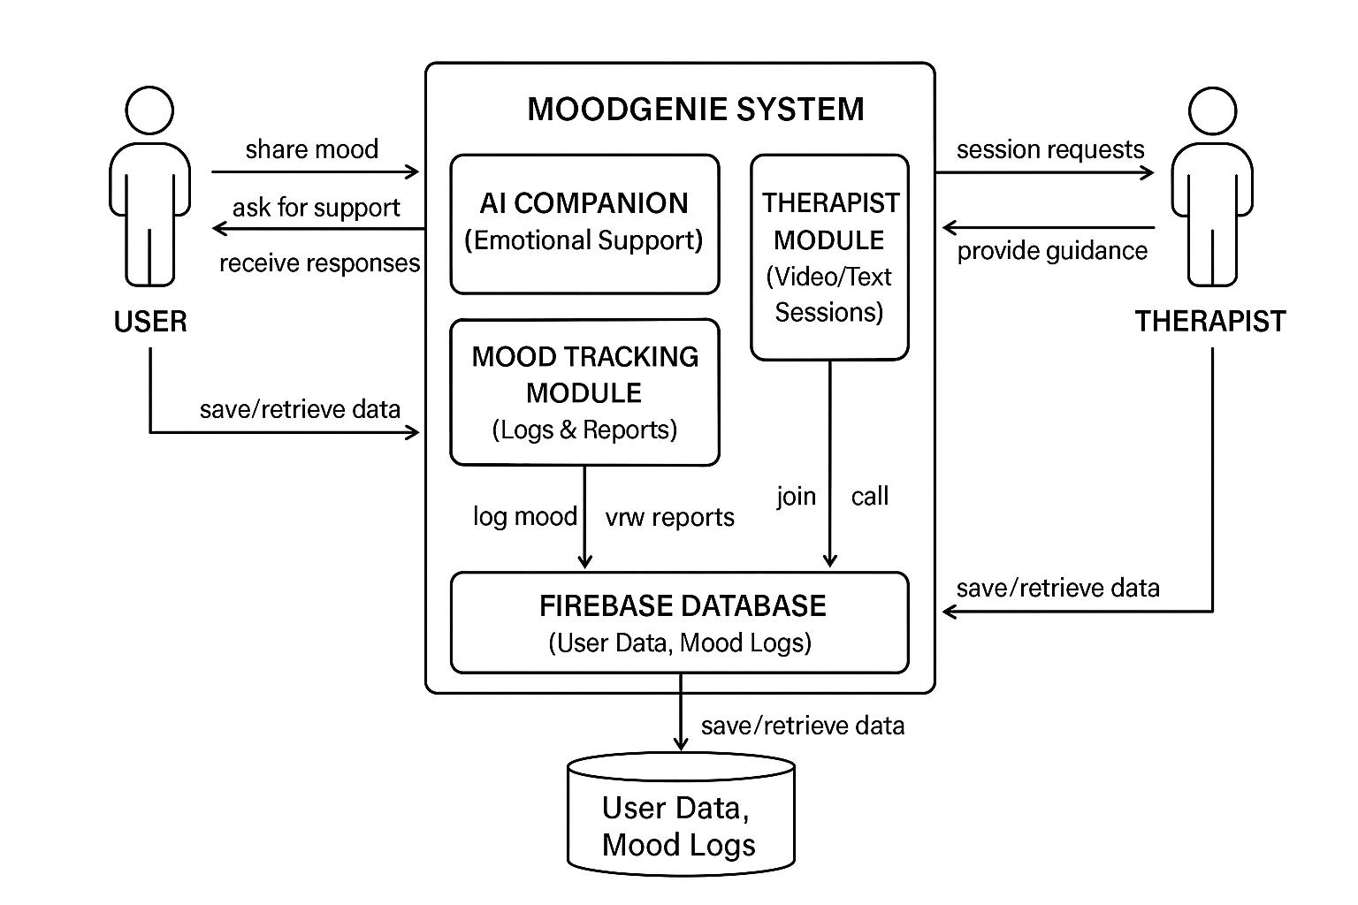
Figure 1: High-Level System Architecture of the MoodGenie Application
This perspective shows how MoodGenie functions as an integrated, modular system built to ensure seamless communication among components while delivering a user-centered mental health support experience.

2.2 Product Functions
MoodGenie provides a set of integrated mental-wellness features designed for software developers, tech students, and research scholars. The primary functions of the product include:
• AI-Driven Emotional Support
Allows users to interact with an empathetic AI companion for mood check-ins, stress management tips, journaling assistance, and conversational self-care guidance.
• Therapist Access and Booking
Enables users to book secure text or video sessions with licensed therapists, view therapist availability, and manage session history.
• Mood Tracking
Supports daily mood logging, capturing emotional state, triggers, activities, sleep quality, and stress levels.
• Mood Analytics and Reports
Generates weekly and monthly visual summaries to help users identify emotional patterns and behavioral trends.
• User Authentication & Account Management
Provides secure sign-up, login, password recovery, and profile management.
• Notification and Reminder System
Sends reminders for mood logging, upcoming therapy sessions, and self-care activities using Firebase Cloud Messaging.
• Data Privacy and Consent Management
Allows users to control access permissions, delete chat histories, and manage what data therapists can view.
• Therapist Dashboard Access (Web)
Therapists can securely access user-consented mood logs, session notes, and schedule future sessions.
The high-level functional architecture of MoodGenie is shown in Figure 2.
It provides a clear overview of how the user interacts with the system’s core modules and how backend services support the core functionality.
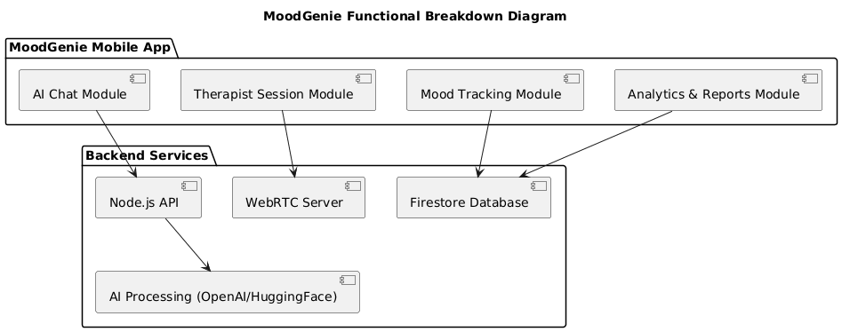
Figure 2: High-Level Functional Breakdown of MoodGenie
2.3 User Classes and Characteristics
MoodGenie will be used by three primary user classes, each having different goals, permissions, and system interactions. These user groups vary in technical literacy, frequency of use, and security privileges.

1. General Users (Developers, Tech Students, Researchers)
Characteristics:
- Basic to advanced technical literacy
- Use the app frequently (daily or weekly)
- Need emotional support, mood tracking, and therapy access
- Privacy-sensitive, require full control of data
- Largest and most important user class
Functions They Use:
- AI Chat Module
- Mood Tracking
- Analytics Dashboard
- Therapist Booking + Video/Text Sessions
- Profile & Consent Settings

2. Licensed Therapists
Characteristics:
- Trained mental health professionals
- Access only when user consents
- Need to view mood reports, session history (limited), and conduct sessions
- Medium usage (sessions scheduled weekly/monthly)
- Higher security clearance
Functions They Use:
- Therapist Dashboard
- Appointment Management
- Secure WebRTC Session Panel
- Session Notes (only if user consents)

3. System Administrators
Characteristics:
- High technical expertise
- Responsible for backend monitoring, therapist verification, and system security
- Low frequency of usage
- Highest privilege level
Functions They Use:
- Manage therapists
- View system analytics
- Maintain database rules
- Monitor API usage
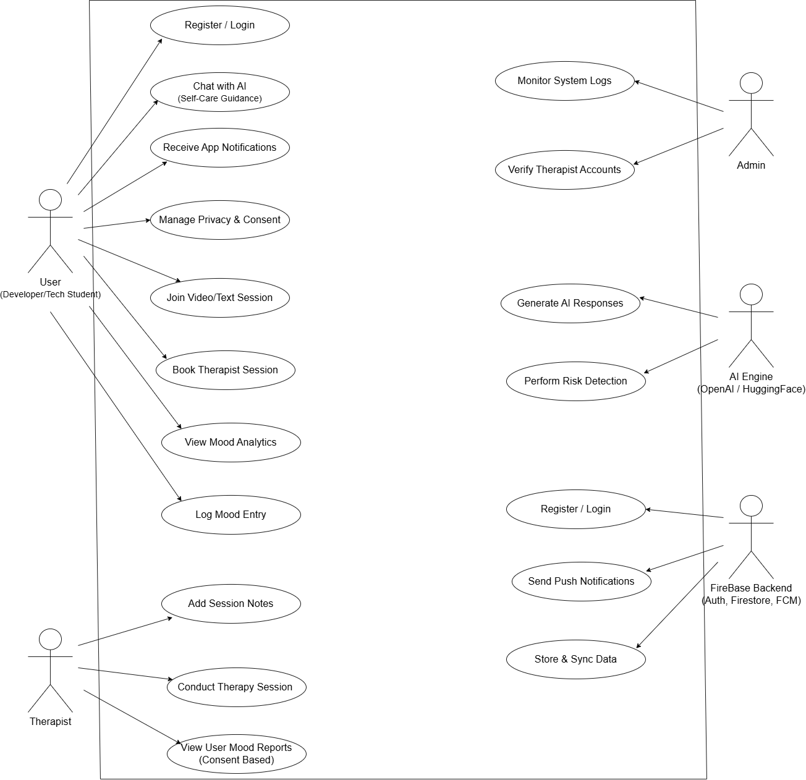

2.4 Operating Environment
The MoodGenie system will operate in a modern mobile and cloud-based environment. The mobile application will run on both Android (Android 10 and above) and iOS (iOS 13 and above) devices equipped with minimum 2 GB RAM, stable internet connectivity, and updated system libraries. The backend services will run on a Node.js (v18+) environment using Express.js frameworks, hosted on a cloud platform such as Firebase which provides Firestore Database, Authentication, and Firebase Cloud Messaging. The system will use OpenAI APIs or compatible AI models hosted on secure cloud servers for generating chatbot responses. Video and audio communication features will operate through WebRTC, requiring supported browsers and mobile OS-level permissions for microphone and camera. All system components must coexist with standard device services such as push notifications, secure storage, and background services without interfering with other applications.

2.5 Design and Implementation Constraints
The development of MoodGenie is subject to several design and implementation constraints. The system must be built using Flutter for cross-platform mobile development, which restricts UI components and performance optimizations to the Flutter framework. The backend must use Node.js and Express.js, limiting the implementation to JavaScript or TypeScript environments. All data storage and authentication must rely on Firebase services, which imposes constraints on database structure, query performance, offline storage, and vendor-specific security rules. The application must comply with privacy and security requirements, including encrypted data transmission, secure handling of mental-health related information, and adherence to consent-based data sharing. Real-time audio and video sessions must use WebRTC, which requires device-level permissions and may face limitations on low-bandwidth networks. Integration with OpenAI APIs or HuggingFace models introduces constraints related to API rate limits, model response time, and token usage costs. The system must function on mobile devices with limited hardware resources, such as restricted memory, battery usage, and varying CPU performance. Additionally, the application must remain compatible with evolving OS policies for background services, notifications, and camera/microphone access.

2.6 User Documentation
The MoodGenie system will include essential user documentation to support onboarding, troubleshooting, and feature understanding. The delivered documentation will consist of an in-app user guide, interactive onboarding tutorials, and FAQ/help-center content accessible from the mobile application. A web-based user manual will also be provided for therapists and administrators, detailing account setup, session management, and dashboard usage. All documentation will follow standard digital help formats, including step-by-step instructions, annotated screenshots, and feature explanations. User support will be delivered in English, with the documentation optimized for mobile viewing and accessible through the application’s Help section.

2.7 Assumptions and Dependencies
The development of MoodGenie relies on several assumptions that may affect system requirements if they change. It is assumed that stable versions of Flutter, Node.js, Firebase services, and OpenAI APIs will remain available throughout the project lifecycle. The system assumes consistent internet connectivity for AI chat responses, therapist sessions using WebRTC, and real-time database updates. It is also assumed that licensed therapists will have access to compatible web browsers and stable internet for using the therapist dashboard. The project depends on third-party components such as Firebase Authentication, Firestore Database, OpenAI APIs, and WebRTC libraries. Any change in pricing, API policies, or service availability of these platforms may affect system functionality, cost, or design decisions. Additionally, the system assumes user devices will run on supported versions of Android or iOS, and that the backend server will operate in a secure cloud environment compatible with project requirements.

3. External Interface Requirements

3.1 User Interfaces
The MoodGenie system will include three primary user interfaces: Mobile Application Interface for end-users, Therapist Dashboard Interface for licensed therapists, and an Admin Panel for system monitoring. The mobile app will use a clean, minimal, and intuitive layout following Material Design 3 standards to ensure usability on both Android and iOS devices. The interface will provide standard navigation elements such as a bottom navigation bar, floating action button for quick mood check-ins, and consistent screen layouts with uniform colors and typography. All screens will include standard elements such as a back button, error message display area, and help icon linking to in-app guidance.
The AI chat screen will support text input, quick action buttons, and message bubbles similar to modern messaging apps. The mood tracker interface will present graphs and mood logs in a structured layout using Flutter chart components. The therapist booking interface will include a calendar view, session selection buttons, and confirmation prompts. The therapist dashboard will provide a web-based UI with role-based access, a left-side navigation menu, session management screens, and consent-based user reports. Error messages will follow consistent formatting, stating the issue and recommended action. Accessibility considerations will include readable font sizes, contrast-compliant colors, and simple navigation structures.

3.2 Hardware Interfaces
MoodGenie will operate primarily on mobile devices and web browsers, requiring no specialized hardware. The system will interface with the following hardware components:

• Smartphones and Tablets:
Compatible with Android (v8.0 or higher) and iOS (v13 or higher). The app interacts with touchscreens, vibration motors (for notifications), microphone, and front-facing camera for WebRTC-based therapist video sessions.
• Therapist Devices (Laptops/PCs):
The therapist dashboard will run on standard desktop or laptop hardware supporting any modern browser with WebRTC capability.
• Camera and Microphone Access:
Required for secure video therapy calls. Interaction includes real-time media capture, encoding, and transmission using WebRTC.
• Network Connectivity:
Wi-Fi or mobile data is required to transmit chat messages, AI requests, therapist session streams, and mood log synchronization.
• Push Notification Hardware:
Uses device-specific notification systems (Android FCM module and iOS APNs) to deliver alerts for sessions and reminders.

No other direct hardware communication is needed apart from OS-managed device sensors and network interfaces.

3.3 Software Interfaces
MoodGenie interacts with several external software systems, APIs, and libraries essential for its operation:

• Operating Systems:
– Android (v8+), iOS (v13+).
– Web browsers (Chrome, Edge, Firefox, Safari) for therapist dashboard.
The application follows OS-level permissions for camera, microphone, notifications, and secure storage.

• Backend Server (Node.js + Express):
Provides RESTful APIs for authentication, mood logs, AI requests, session scheduling, and user profile management. Handles JSON-based requests and responses via HTTPS.

• Firebase Services:
– Firebase Authentication: For secure login via email, phone, or OAuth.
– Firestore Database: Stores user profiles, mood logs, therapist schedules, and chat summaries.
– Firebase Cloud Messaging (FCM): Sends push notifications.
Data is exchanged in structured JSON format.

• OpenAI API:
Used for generating empathetic chatbot responses. Inputs include user messages and mood context. Outputs are model-generated text responses, transmitted through secure HTTP requests.

• HuggingFace Models:
Used for sentiment analysis and risk detection. The app sends text samples to the model endpoint and receives classification results (positive, neutral, negative, risk flags).

• WebRTC Module:
Handles secure peer-to-peer video and audio streaming between user and therapist. Requires STUN/TURN servers to establish reliable communication.

• Flutter Framework (Frontend):
Uses Dart libraries for UI rendering, HTTP communication, charting packages for mood analytics, and local data storage.

• Admin Panel Tools (Optional):
May use Firebase Console for monitoring logs, analytics, and backend rules.

All interactions use secure HTTPS communication, follow JSON data structures, and comply with platform API requirements. No global data sharing is required beyond authenticated API transactions, and all stored data is encrypted in Firestore according to Firebase security rules.

3.4 Communications Interfaces
MoodGenie relies on secure, real-time, and reliable communication channels to support chat processing, data synchronization, and therapist video sessions. The communication requirements are as follows:

• Network Protocols:
The system uses HTTPS for all API communication between the mobile app, backend server, and Firebase services. WebRTC utilizes SRTP (Secure Real-Time Protocol) for encrypted audio and video transmission.

• Message Formatting:
All client–server interactions follow standardized JSON message formats for sending and receiving data such as chat queries, mood logs, authentication responses, and therapist schedules.

• Real-Time Communication:
WebRTC is used for peer-to-peer therapist video calls. It requires STUN/TURN servers to establish reliable connections, especially behind firewalls or NAT networks.

• Data Synchronization:
Firestore supports real-time data syncing for chat summaries, mood entries, session updates, and therapist availability. Changes are propagated instantly to users and therapists.

• Push Notifications:
Firebase Cloud Messaging (FCM) is used to deliver real-time alerts, including session reminders, mood check-in prompts, AI responses (if needed), and analytics notifications.

• Security and Encryption:
– All communications follow TLS 1.2+ encryption.
– WebRTC streams are protected using DTLS-SRTP.
– User authentication uses Firebase secure tokens.
– Sensitive messages such as therapy notes and mood analytics are encrypted at rest and in transit.

• Supported Bandwidth:
– Minimum 1–2 Mbps recommended for smooth video sessions.
– Standard mobile network speeds (3G/4G/5G or Wi-Fi) are sufficient for chat and mood tracking features.

• Browser Compatibility:
The therapist dashboard supports WebRTC-enabled browsers, including Chrome, Firefox, and Safari.

MoodGenie ensures reliable, secure, and privacy-focused communication across all modules, enabling seamless interaction between users, AI services, and therapists.

4. System Features

4.1 AI Emotional Support Chat

4.1.1 Description and Priority

This feature provides users with a 24/7 empathetic AI chatbot for emotional support, mood check-ins, journaling prompts, and coping strategies based on CBT and mindfulness.
Priority: High

4.1.2 Stimulus/Response Sequences

• User opens the AI chat screen
→ System loads previous chat history
→ User sends a message
→ System forwards message to OpenAI API
→ AI generates a response
→ App displays the response and logs mood indicators

• User selects a self-care activity
→ System displays guided breathing or journaling prompts

4.1.3 Functional Requirements

REQ-AI-1: The system shall send user messages to the AI model and return an empathetic response.
REQ-AI-2: The system shall maintain chat history for each user.
REQ-AI-3: The system shall classify messages for sentiment and risk using HuggingFace models.
REQ-AI-4: The system shall notify the user if the message indicates emotional distress.
REQ-AI-5: The system shall gracefully handle API failures and display fallback responses.

4.2 Therapist Booking & Video Sessions

4.2.1 Description and Priority

This feature allows users to book licensed therapists and conduct encrypted video or text sessions through WebRTC.
Priority: High

4.2.2 Stimulus/Response Sequences

• User selects a therapist
→ System displays available time slots
→ User books a slot
→ System sends confirmation and adds to therapist dashboard

• At session time
→ System launches WebRTC call
→ Both sides connect securely
→ System logs session duration

4.2.3 Functional Requirements

REQ-THER-1: The system shall allow users to view therapist profiles and availability.
REQ-THER-2: The system shall allow users to book, cancel, or reschedule sessions.
REQ-THER-3: The system shall support encrypted real-time video calls via WebRTC.
REQ-THER-4: The system shall notify both user and therapist before session start.
REQ-THER-5: The system shall prevent access to video sessions without authentication.

4.3 Mood Tracking & Analytics

4.3.1 Description and Priority

This feature logs daily emotional states and generates weekly and monthly analytics for stress trends.
Priority: Medium–High

4.3.2 Stimulus/Response Sequences

• User logs mood
→ System stores entry and updates charts

• User opens analytics
→ System fetches emotion history
→ System renders graphs and insights

4.3.3 Functional Requirements

REQ-MOOD-1: The system shall allow users to record daily mood with emojis, text, and optional notes.
REQ-MOOD-2: The system shall generate visual charts for weekly and monthly trends.
REQ-MOOD-3: The system shall store mood logs in Firestore.
REQ-MOOD-4: The system shall allow exporting reports to PDF.
REQ-MOOD-5: The system shall ensure no analytics is generated without valid data.

4.4 User Authentication & Privacy Controls

4.4.1 Description and Priority

This feature ensures secure login, data encryption, and user control over privacy and consent.
Priority: High

4.4.2 Stimulus/Response Sequences

• User opens the app
→ System loads login screen
→ User signs in
→ System verifies credentials through Firebase Auth
→ System redirects to dashboard

• User manages privacy
→ System applies settings (delete data, restrict access)

4.4.3 Functional Requirements

REQ-AUTH-1: The system shall authenticate users using Firebase Authentication.
REQ-AUTH-2: The system shall encrypt all sensitive data in transit (TLS 1.2+).
REQ-AUTH-3: The system shall allow users to delete chat history and logs.
REQ-AUTH-4: The system shall restrict therapist access unless consent is given.
REQ-AUTH-5: The system shall log out users automatically after inactivity.

5. Other Nonfunctional Requirements

5.1 Performance Requirements
<If there are performance requirements for the product under various circumstances, state them here and explain their rationale, to help the developers understand the intent and make suitable design choices. Specify the timing relationships for real time systems. Make such requirements as specific as possible. You may need to state performance requirements for individual functional requirements or features.>

5.2 Safety Requirements
<Specify those requirements that are concerned with possible loss, damage, or harm that could result from the use of the product. Define any safeguards or actions that must be taken, as well as actions that must be prevented. Refer to any external policies or regulations that state safety issues that affect the product’s design or use. Define any safety certifications that must be satisfied.>

5.3 Security Requirements
<Specify any requirements regarding security or privacy issues surrounding use of the product or protection of the data used or created by the product. Define any user identity authentication requirements. Refer to any external policies or regulations containing security issues that affect the product. Define any security or privacy certifications that must be satisfied.>

5.4 Software Quality Attributes
<Specify any additional quality characteristics for the product that will be important to either the customers or the developers. Some to consider are: adaptability, availability, correctness, flexibility, interoperability, maintainability, portability, reliability, reusability, robustness, testability, and usability. Write these to be specific, quantitative, and verifiable when possible. At the least, clarify the relative preferences for various attributes, such as ease of use over ease of learning.>

5.5 Business Rules
<List any operating principles about the product, such as which individuals or roles can perform which functions under specific circumstances. These are not functional requirements in themselves, but they may imply certain functional requirements to enforce the rules.>
5.6 Detailed Subsystem Design
Provide a detailed description of this software component (or a reference to such a description). Complex diagrams showing the details of component structure, behavior, or information/control flow may be included in the subsection devoted to that particular component (although, unless they are very large or complex, some of these diagrams might be more appropriately included in the System Architecture section. The description should cover any applicable software component attributes (some of which may be adequately described solely by a source code declaration or excerpt).
Draw following diagrams according to your project
- Use case Diagram
- ER Diagram
- Architectural Diagram
- Activity Diagram
- Sequence Diagram
- Component Diagram
- State Machine Diagram
- Class Diagram
- Data Flow Diagram
- Database Diagram

References
<List any other documents or Web addresses to which this SRS refers. These may include user interface style guides, contracts, standards, system requirements specifications, use case documents, or a vision and scope document. Provide enough information so that the reader could access a copy of each reference, including title, author, version number, date, and source or location.>

